Sound is produced by vibration of an object
Vibrations determine oscillation of air molecules
Alternation of air pressure causes a wave

y(t)= A Sin (2 pi f t + fi)

ADC sample rate: we take more than 40000 amplified points in a second

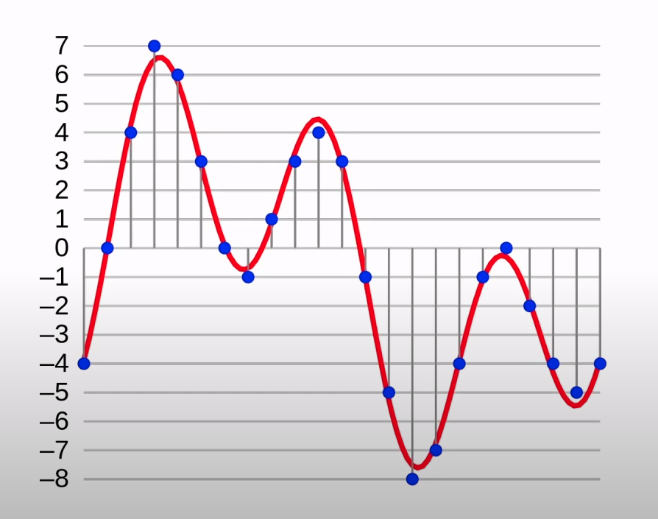

Why chose MFCC
https://arxiv.org/pdf/1706.07156.pdf

Fourier transform

Decompose complex periodic sound into sum of sine waves oscillating at different frequencies.
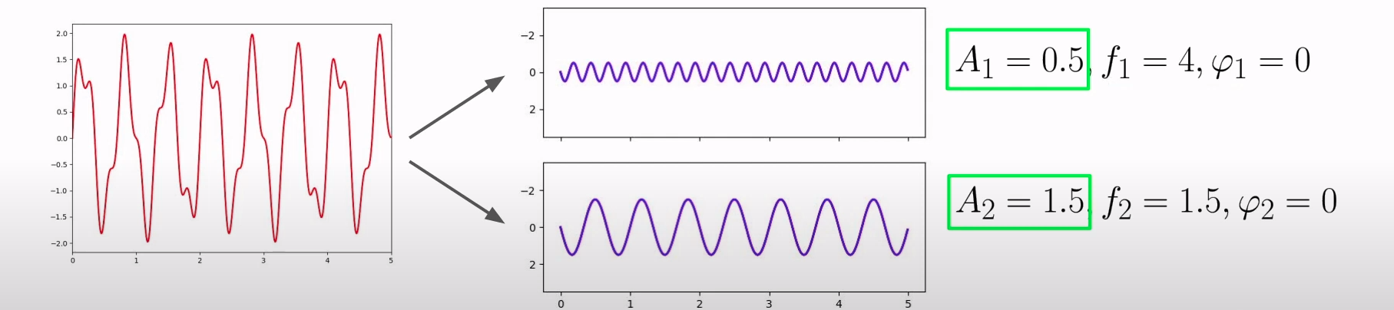

Deep learning for audio data is based on Spectrogram (db)

New one, Mel Frequency Cepstral Coefficients (MFCC)

Capture timbral/textural aspects of sound
Frequency domain feature
Approximate human auditory system
13 to 40 coefficients (13 is the best depending on my experiment
MFCC sample rate: we take more than 22050 amplified points in a second

Prepare the data:

convert the sound to wave
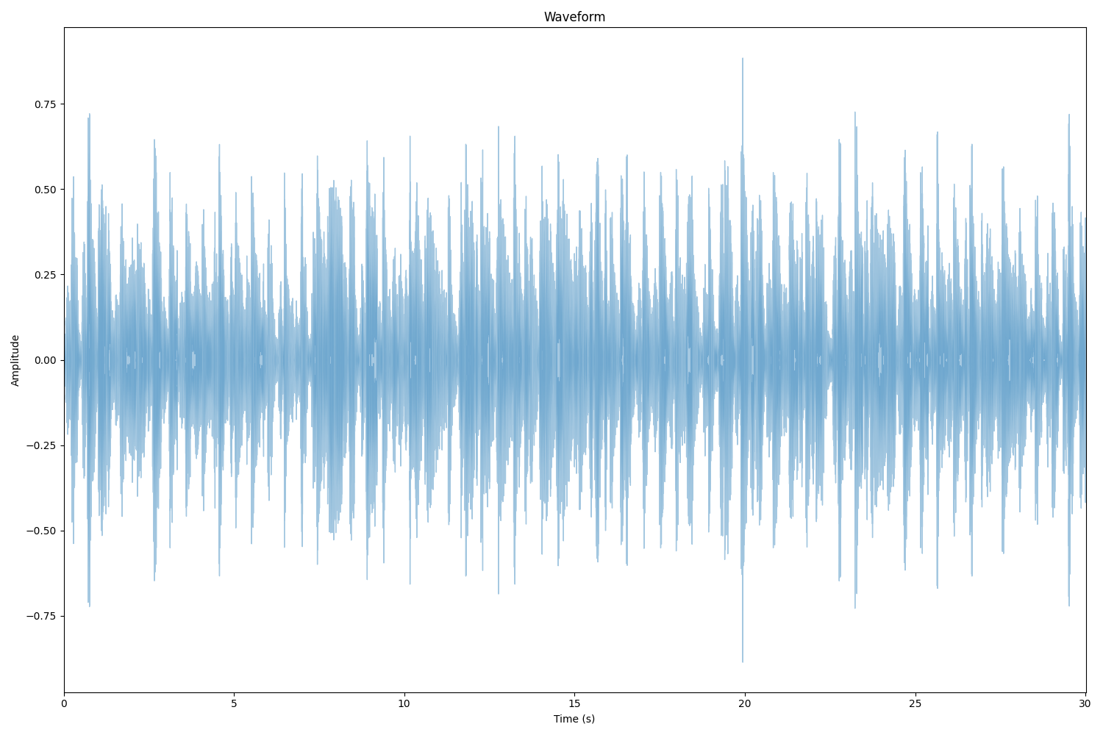

Copare STFT VS MFCC

Result of Short Time Fourier Transform (STFT)
Gives a spectrogram (time + frequency + magnitude)

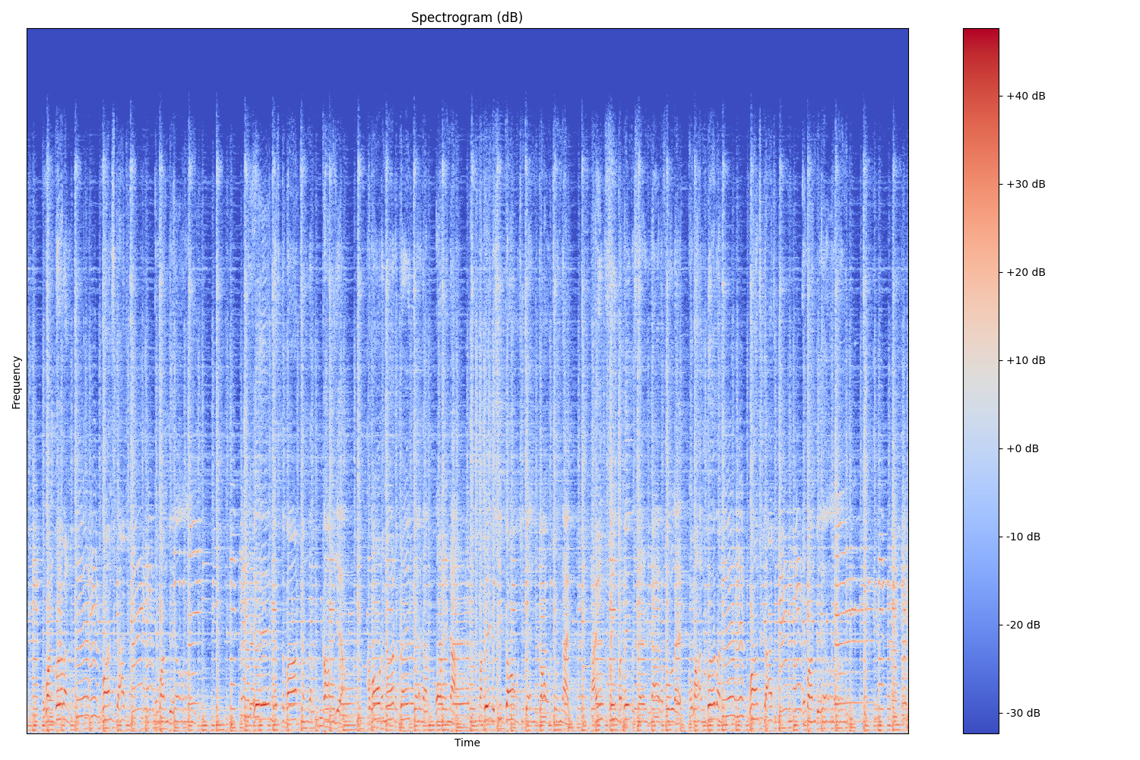

This is The MFCC result:
